### **Licensing SQL Server 2014 for High Availability**

<https://www.faceofit.com/licensing-sql-server-2014-for-high-availability/>

Today, more and more SQL Server’s are being deployed in a High availability scenario,  using various technologies available, such as Database Mirroring, Log shipping, Hardware Clustering, Replication or Always On availability groups. In some cases, SQL Server’s are being [deployed on a Virtual Machine](https://www.faceofit.com/sql-server-licensing-in-a-vm/), which in itself is highly available.

Let’s talk about the various scenario’s in HA & DR with SQL Server and how to properly license them.

You need to buy **Software Assurance** for all SQL Server’s which needs to have a “Warm” passive server for failover purposes. The SA (Software Assurance) benefit will ensure “**License Mobility Rights**” so that you do not need to buy additional licenses for the failover partner.

***Note: You cannot run any workloads(Reporting, Querying etc.) on the secondary server. If you do, you need to “Fully” license the second SQL Server. Only Standby servers are supported.***

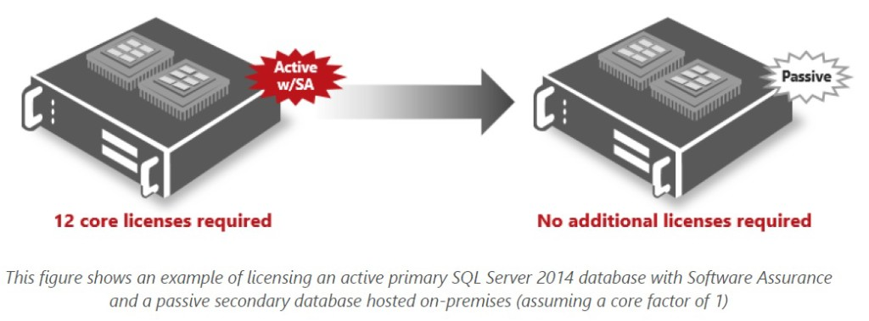

***Source: Microsoft Licensing Guide for SQL 2014***

In the following scenario, One location is covered under the SA benefit. However, since there are 2 secondaries, you need to purchase the required number of licenses for maintaining two DR sites.

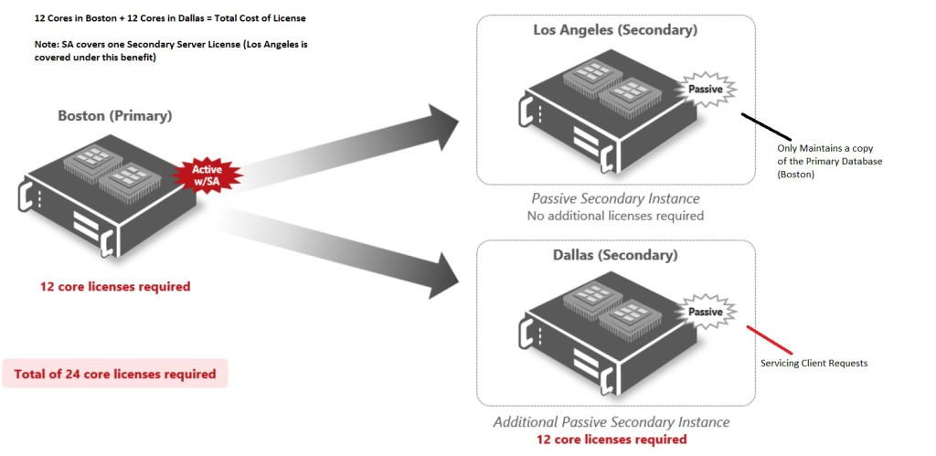

*Source: Microsoft Licensing Guide for SQL 2014*

### **Licensing SQL Server 2014 under the**[**Per Core model**](https://www.faceofit.com/sql-server-2014-core-licensing/)**:**

* The Server which has more CPU Cores needs to be covered under the [Core based licensing method](https://www.faceofit.com/sql-server-2014-core-licensing/).
* If your primary server has 6 core, and the secondary passive site has 8, you need to buy 8 licenses with Software assurance to cover both the installations.
* In case of a failover, the License is dynamically assigned to the secondary server under the “License Mobility Rights”
* In case of Always On Availability groups, all SQL Servers servicing active server workloads needs to be fully licensed.
* ***For Always On Availability Groups, if the Secondaries are using “Read Intent”, “Read-Only” or “Backup Server”, then they need to be fully licensed.***